Demonstrate virtualization by Installing Type-2 Hypervisor in your device, create and configure VM image with a Host Operating system (Either Windows/Linux).

Procedure

Step1: Creating a Duplicate Virtual machine.

Clicking NEXT Button by default.

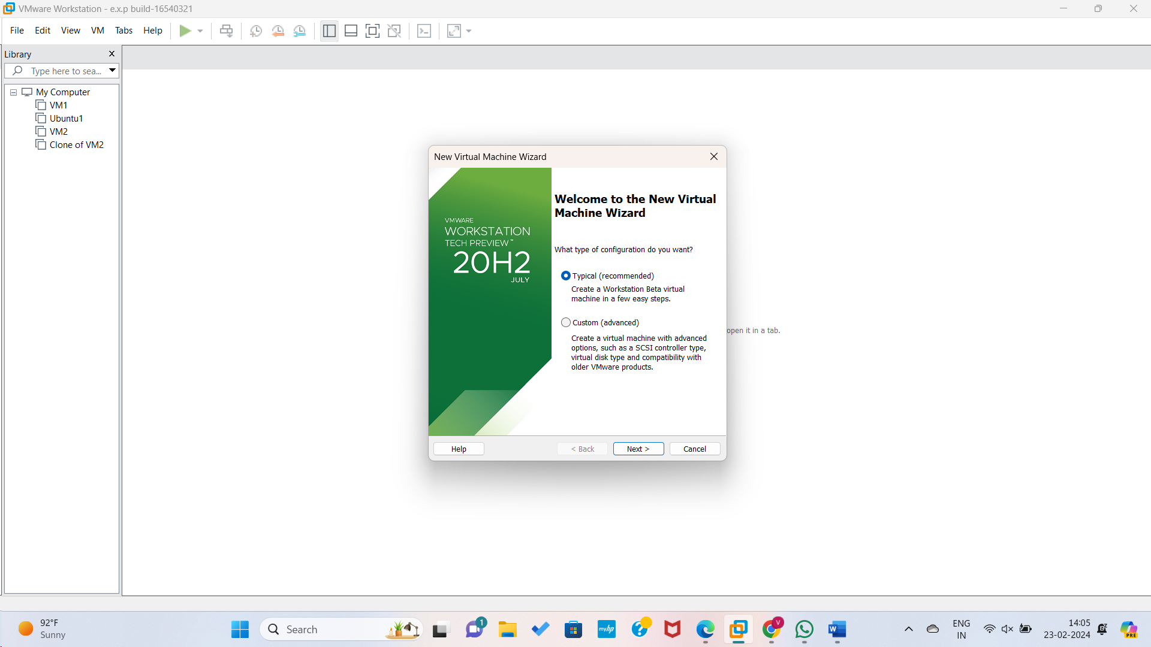

Step2: Choosing Guest Operating systems and clicking NEXT Button.

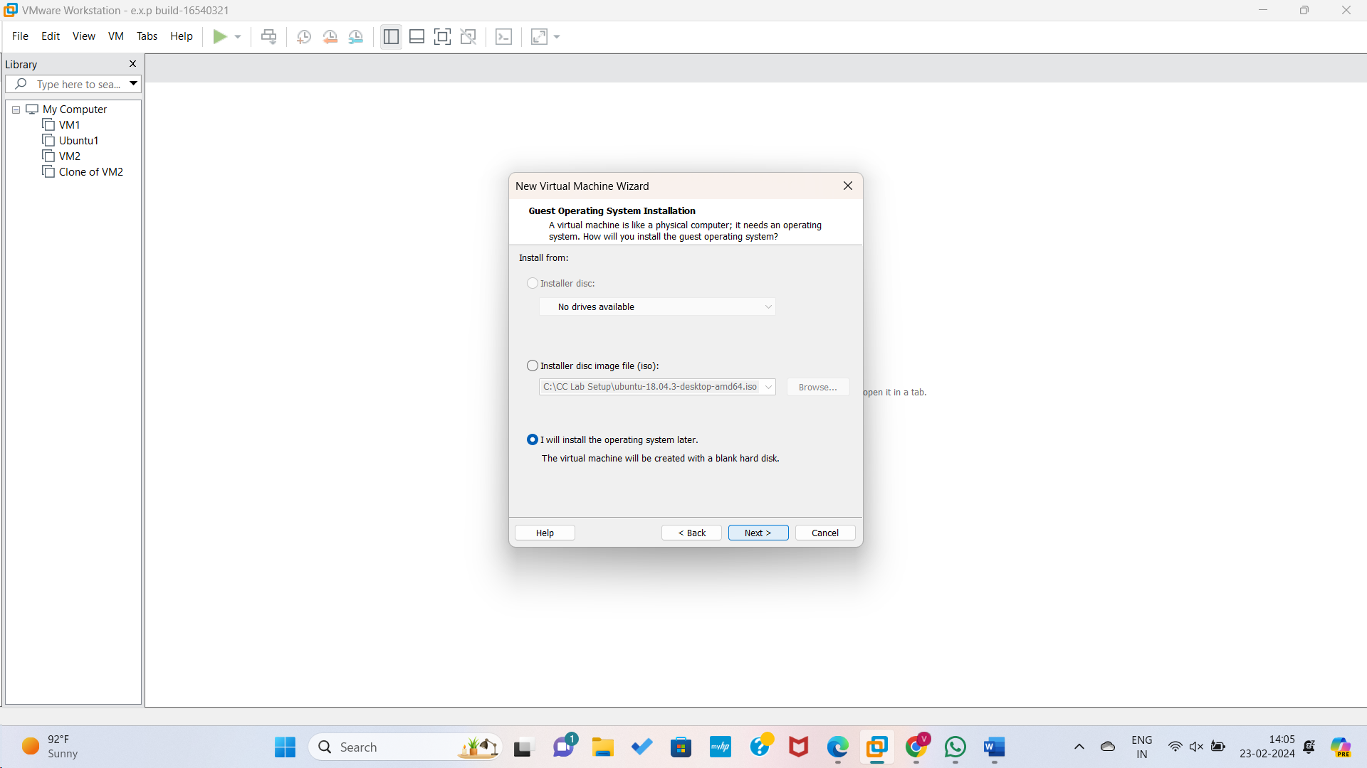

Step3: Choosing the operating system name and Clicking NEXT Button

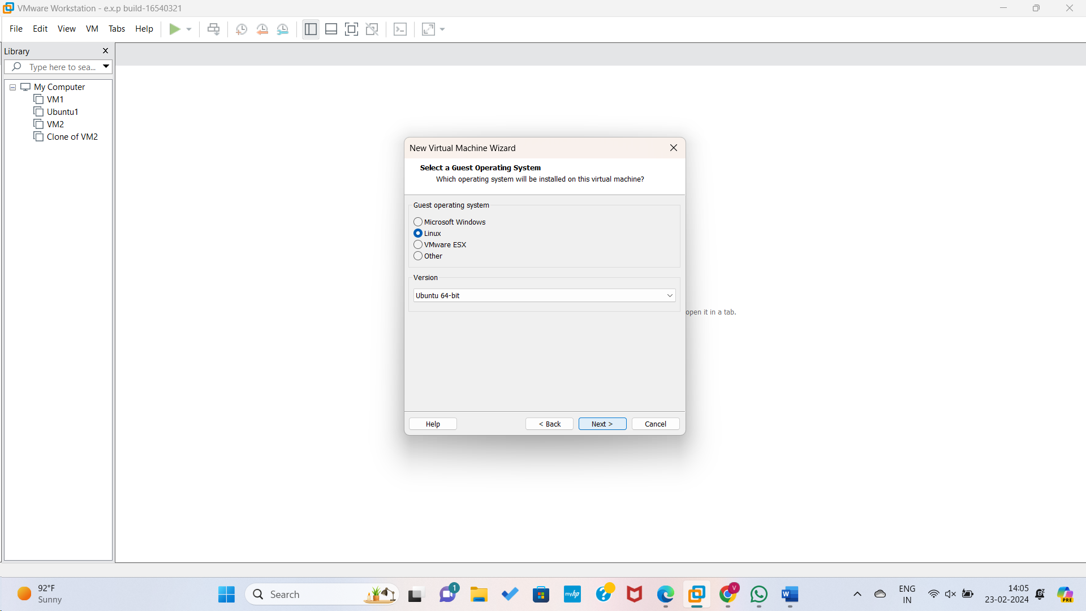

Step4: Giving name for virtual machine.

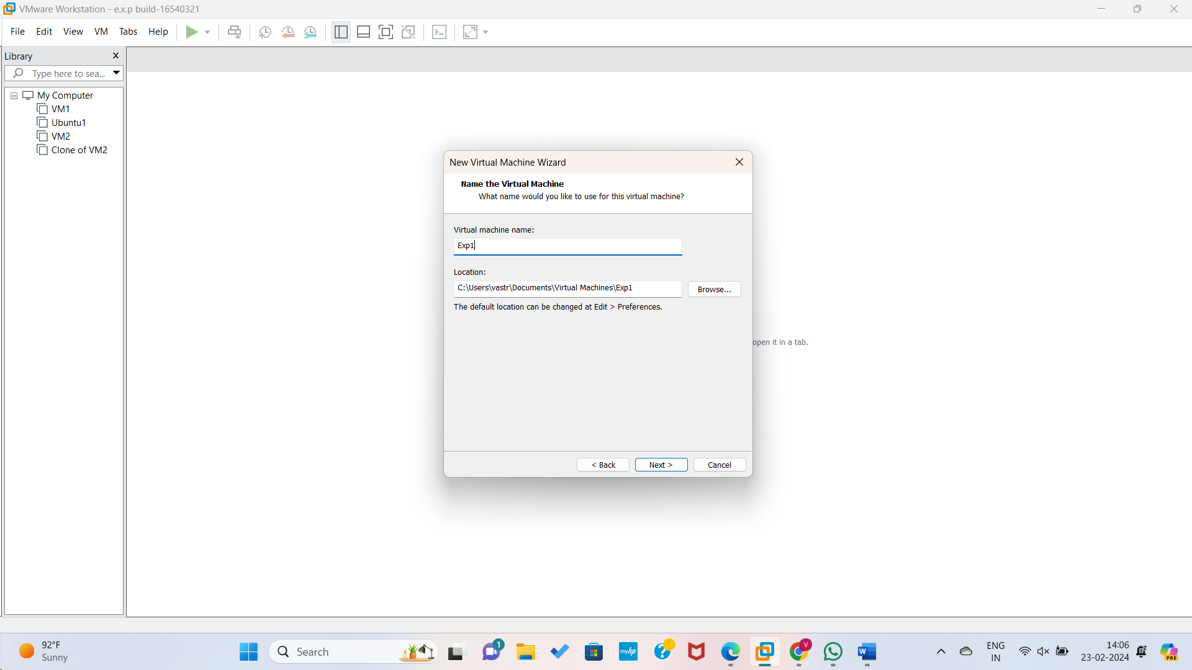

Step5: Selecting Memory disk.

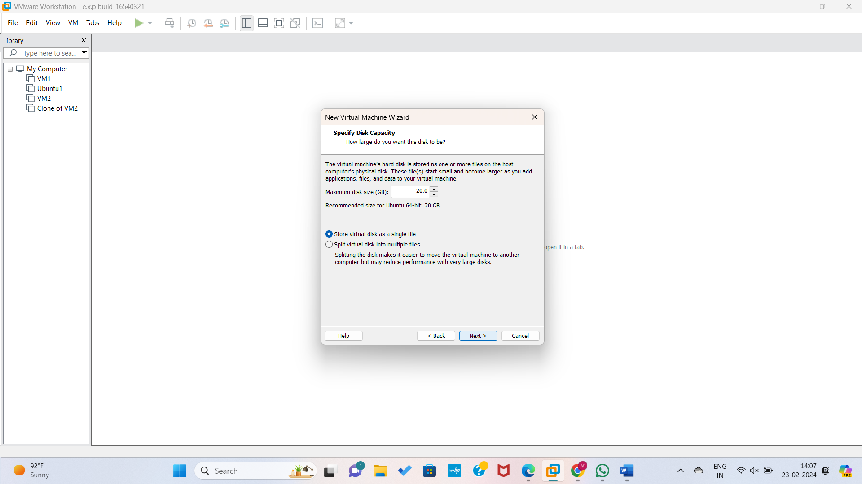

Step7: Viewing Summary details and if needed any changes in settings by clicking customize hardware we can change..

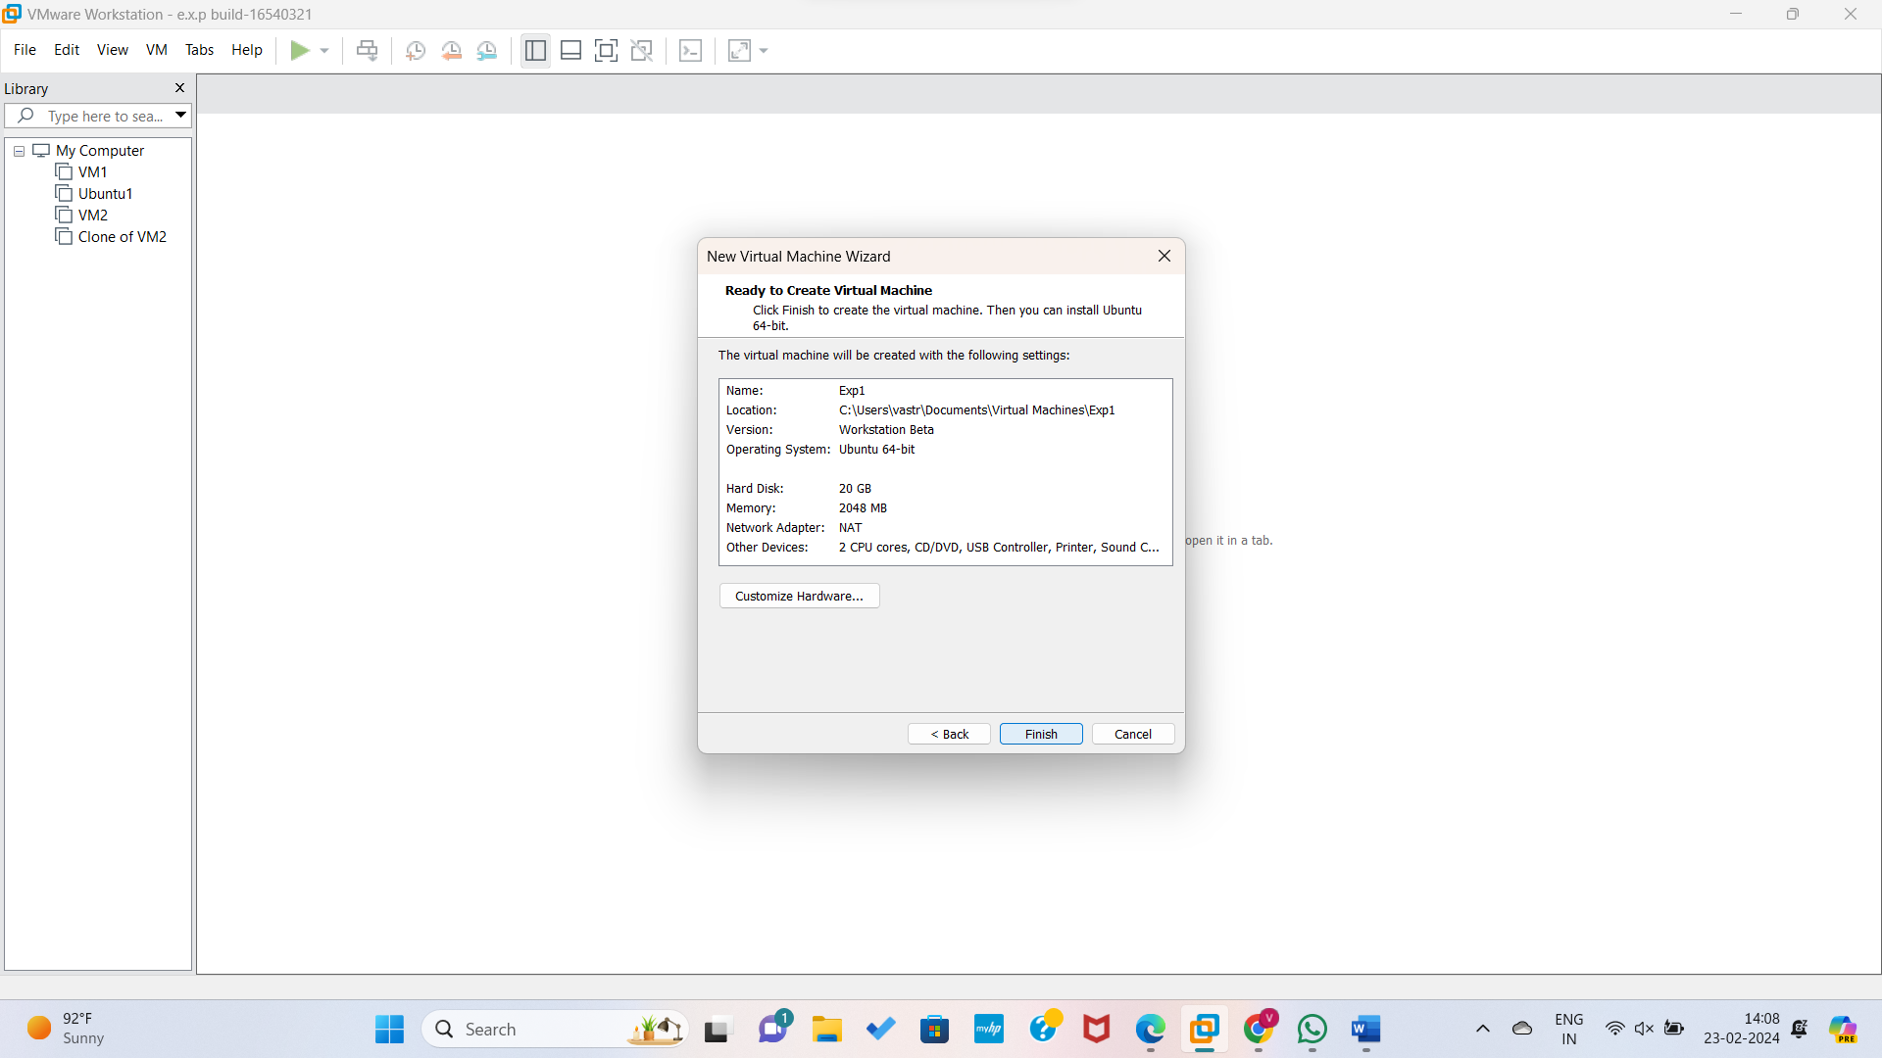

Step8: By finishing all the customs the Virtual machine is displayed.

